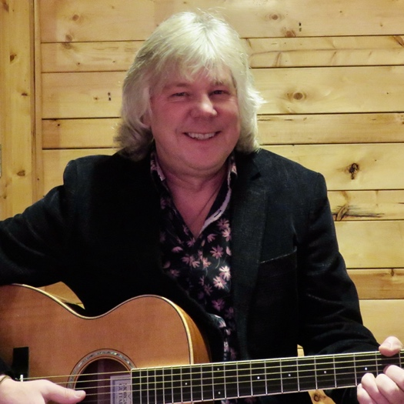 | Marv Machura  Biography  “A crowd favourite.”  “A winning singer and talented guitar player.”  “One-of-a-kind, energetic, artistic, and engaging performer.”
Marv Machura is a “singing guitarist.” He is a performer with many years’ experience entertaining audiences of all ages. He is equally at home performing in pubs, restaurants, events, concerts, homes, patios, wineries, and festivals.
Marv Machura is a versatile artist who mixes new and classic country, rock, folk, and blues songs that all fit together with his likeable and personable shows.
Marv Machura loves to entertain and uplift events, occasions, and venues with the magic of live music. He does not use any backing tracks or other types of electronic aids such as tablets and lyric sheets. He prefers to keep it simple and engaging with just his guitar, voice, and connection with the audience and the particular needs of the venue and show.
Marv Machura also is a singer-songwriter in his own right. He has released four acclaimed CDs, many singles, published 20+ songs in Nashville, and has performed at many Western Canadian music festivals over his career such as The Edmonton Folk Festival.
For more information, please contact Marv Machura through www.marvmachura.com or call/text 250-307-1505.
Biographic Notes: Marv Machura started performing professionally in wedding/dance bands as a teen. As soon as he turned 18, he began working as a singing guitarist in the bars and lounges around his hometown of Edmonton. He started writing songs in the 1980s, publishing songs in Nashville and being featured at many country and folk festivals. In 1990s and 2000s, he formed and led several bands that eventually morphed into the Marv Machura Band (a three-piece folk-rock band). Upon moving to Vernon, BC, in 2013, Marv Machura returned to his solo-performer roots, and he currently enjoys playing all over the Okanagan and Thompson Valleys while he continues to write, record, and perform his own Western Canadian Roots music.
“Music makes the most of each moment!” – Marv Machura

